Market research
Having demonstrated the use of our MVP to multiple people who both do computer science and who don’t I was then able to collect information on how the different users found the experience and what they think of the current state of the product.
Our chosen form of collecting information was through a Microsoft form. This is because it has an intuitive design that had all of the features, we needed to create a form that best fit our needs. Moreover, Google forms has a useful feature for distributing the forms to people by inputting their emails and it distributing it to them.
In this form we asked a number of different questions to gather information about a range of different aspects.
Screen they were shown:
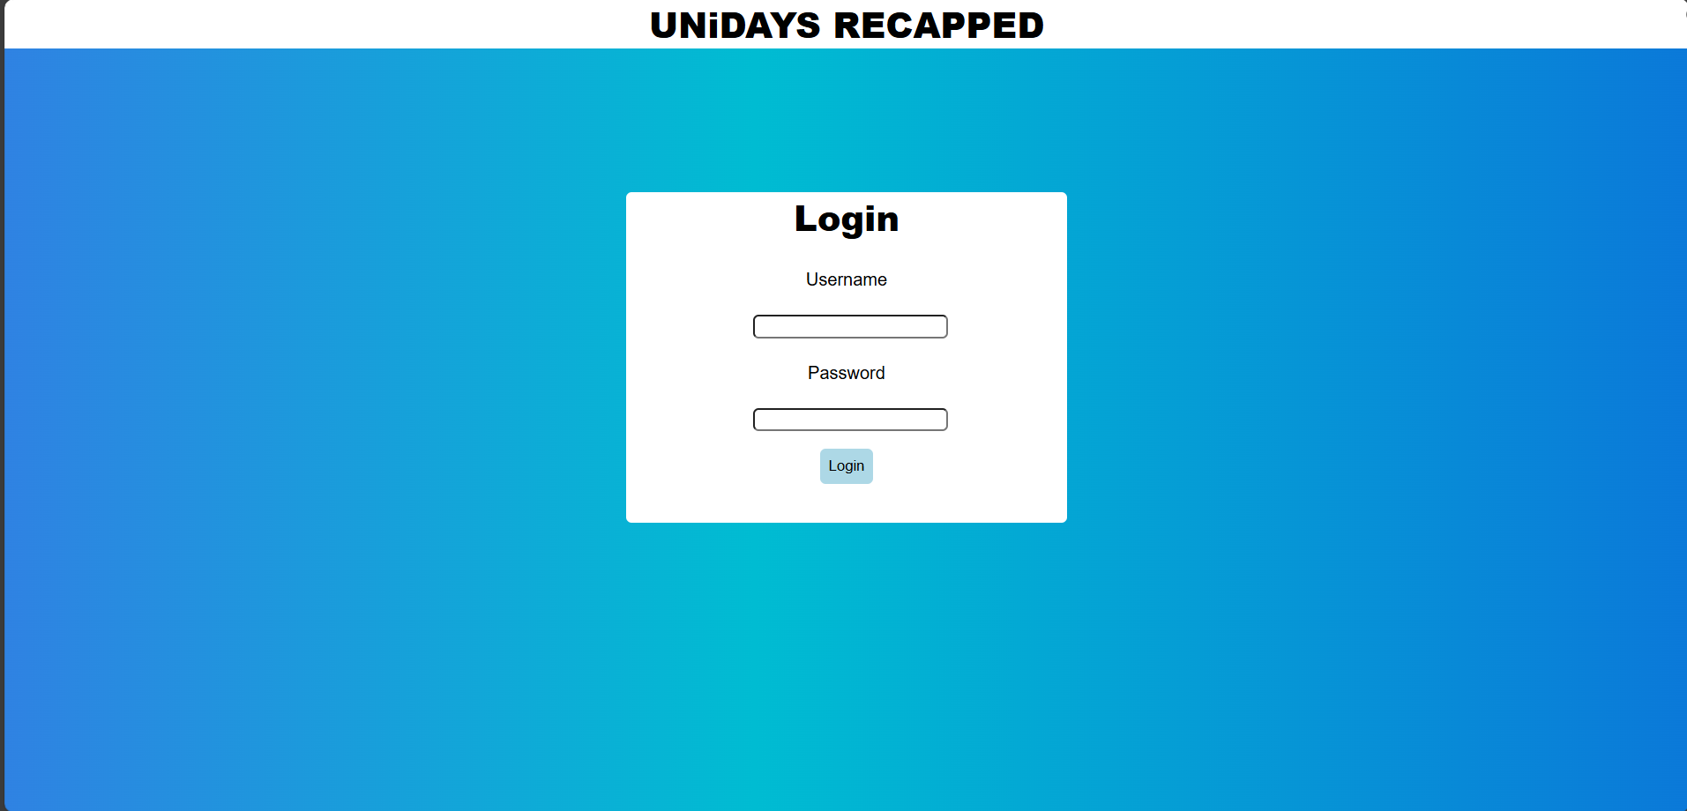
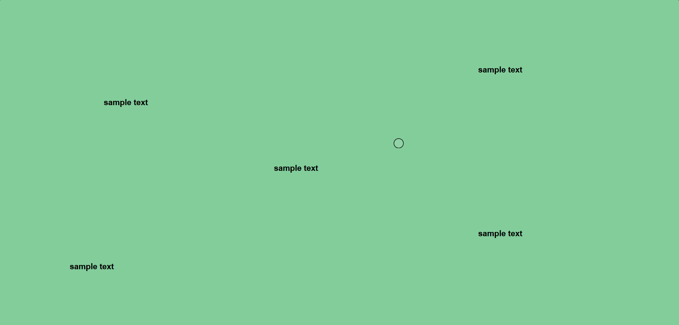
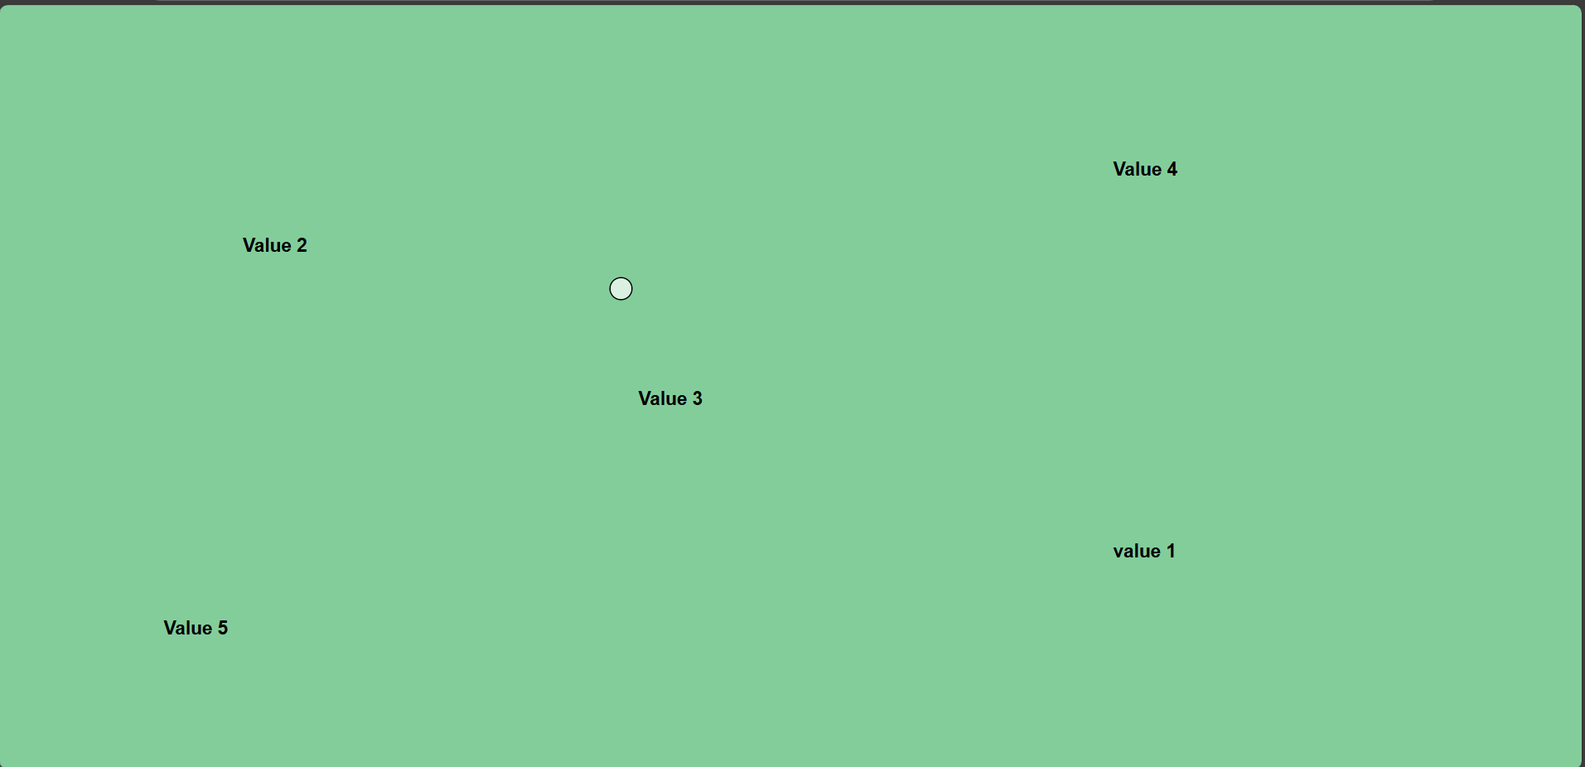

- 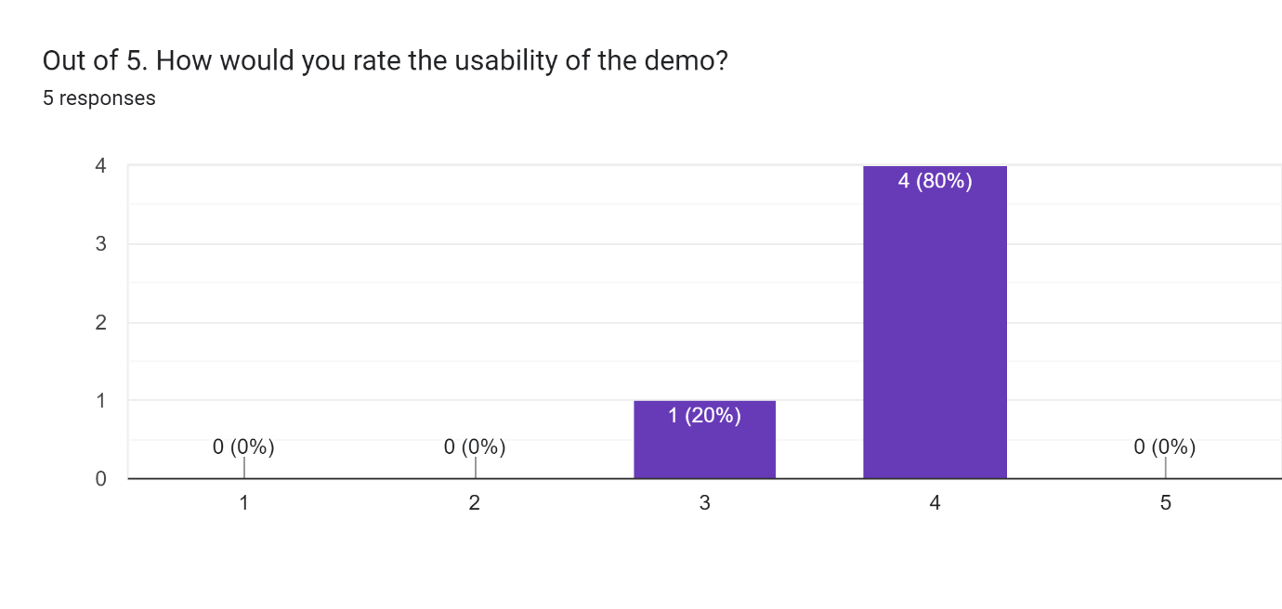
This information reveals that while we have a mostly usable demo there will be small changes required to improve the quality of life we are able to provide with this project.
- 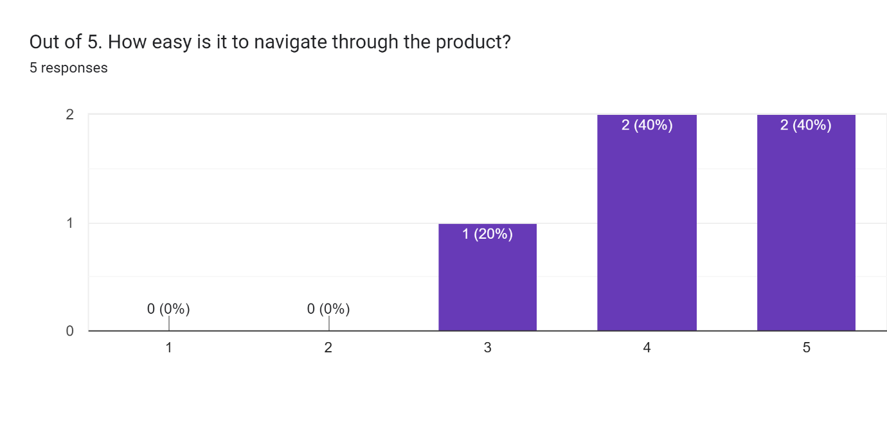
This information reveals that the demo we provided to people was of a simple and easy layout that navigating was simple enough to prove of mode of 4 & 5. However, one user appear to have trouble navigating, this will require investigation as to that the hardest parts are. It I suspected to be to do with the lack of logout button making it difficult to change users.
- 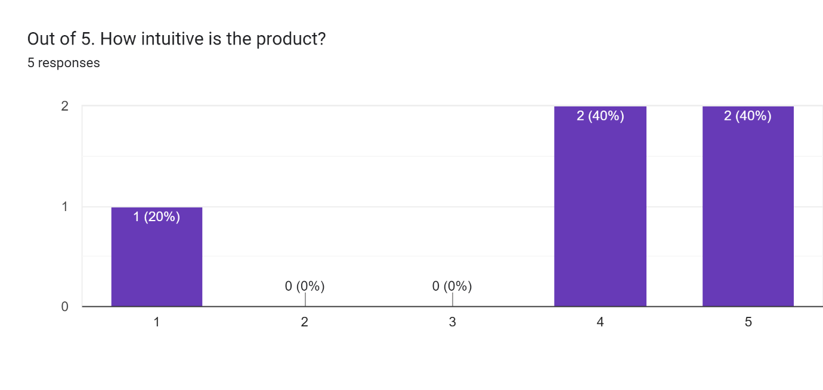
Like the previous question. This question averages high results with the majority being 4 or 5 while there is one outlier here with someone voting one, this should be looked into before the next iteration of the product.
- 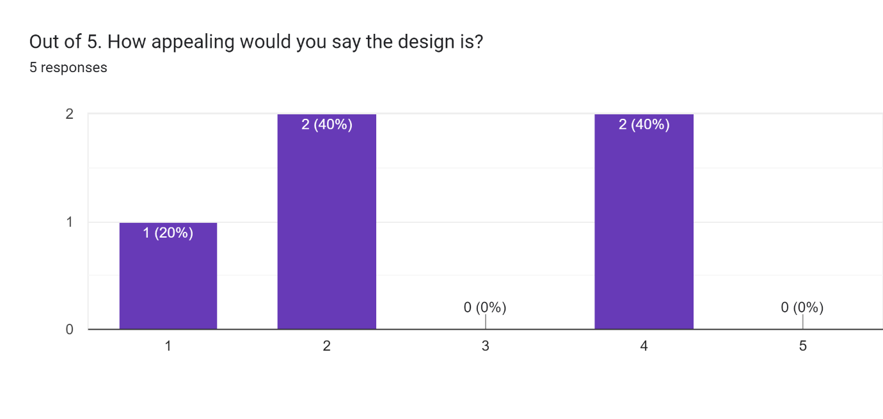
This question appears to yield a considerably lower average than previous questions meaning that our current design of the product isn’t very appealing which means that we should invest time into improving how the product looks before we release the final version of the product.
- 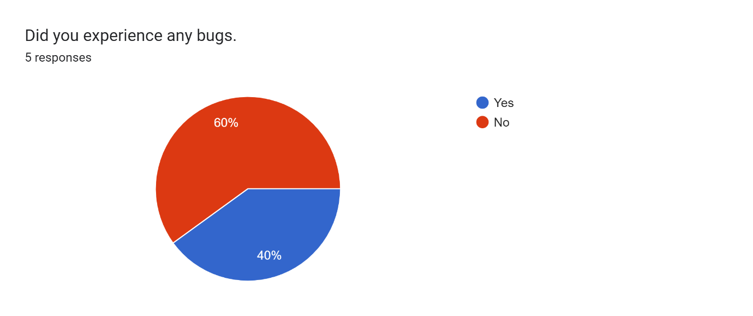
This graph reveals that 40% of users have discovered bugs which is a rather large percentage. However, due to the small sample size it is not a perfect example to go off.
- What were the bugs that you discovered? (If you answered no to the previous question, leave this blank.)
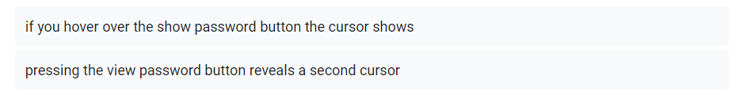
These comments reveal that both people who found bugs stated that when you press the show password button it reveals a second cursor. This should be a relatively easy fix and its not a website breaking bug.
- What features would you like to see added improve the product, if any?
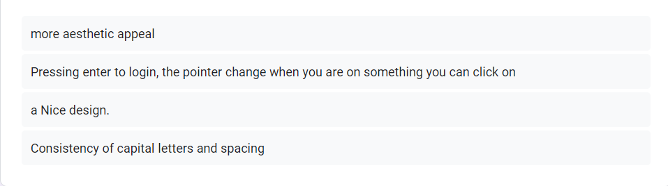
These results reveal that the majority of the test group would like mostly changes to the UI. While on one person would like increased functionality to logging in to increase usability by pressing “enter”.
- What would you like to see removed from the product, if anything?
This questions reveals that we haven’t included any unnecessary features in the product and have kept it simplified.

